**FITFLEX**-Your personal fitness companion

1. **INTRODUCTION**

FitSphere is an easy-to-use fitness website designed to help people stay healthy and active. It offers workout tips, nutrition guidance, and progress tracking tools so users can achieve their fitness goals from anywhere.

**FITFLEX YOUR PERSONAL COMPANION**

* **Project Title**: **Fit flex**
* **Team ID:** NM2025TMID39829
* **Team Leader:** 
  + THIRISHA S (email id: thirishasivakumar2007@gmail.com)
* **Team members:** 
  + DHANALAKSHMI S (email id: dhanalakshmi2006i@gmail.com)
  + GAYATHIRI J (email id: jaishankergayathri@gmail.com)
  + VINITHA V (email id: [vinithavaratharaj17@gmail.com](mailto:vinithavaratharaj17@gmail.com))

1. **PROJECT OVERVIEW**

* **PURPOSE:** The overarching aim of FitSphere is to offer an accessible platform tailored for individuals passionate about fitness, exercise, and holistic well-being.

### FEATURES:

* **Exercises from Fitness API:** Access a diverse array of exercises from reputable fitness APIs, covering a broad spectrum of workout categories and catering to various fitness goals.
* **Visual Exercise Exploration:** Engage with workout routines through curated image galleries, allowing users to explore different exercise categories and discover new fitness challenges visually.
* **Intuitive and User-Friendly Design:** Navigate the app seamlessly with a clean, modern interface designed for optimal user experience and clear exercise selection.
* **Advanced Search Feature:** Easily find specific exercises or workout plans through a powerful search feature, enhancing the app's usability for users with varied fitness preferences.

1. **ARCHITECTURE**

### 1. ****Frontend (Client-side)****

This is what the users interact with directly in the browser or mobile app.

#### Technologies:

* **HTML/CSS/JavaScript**
* **Frontend Frameworks**:
  + React, Vue.js, Angular
* **Mobile apps** (optional):
  + React Native, Flutter, Swift (iOS), Kotlin (Android)

**Backend (Server-side)**

Handles business logic, data processing, authentication, and communication with databases and external services.

#### Technologies:

* Node.js, Django, Ruby on Rails, Laravel, or ASP.NET
* REST or GraphQL APIs
* Authentication frameworks (OAuth2, JWT, Firebase Auth)

#### :

### 3. ****Database****

Stores all the persistent data.

#### Common Databases:

* **Relational (SQL)**: PostgreSQL, MySQL
* **NoSQL**: MongoDB, Firebase Firestore
  1. **SETUP INSTRUCTIONS:**

Here are the key prerequisites for developing a frontend application using React.js:

**Node.js and npm**:

* Node.js is a powerful JavaScript runtime environment that allows you to run JavaScript code on the local environment. It provides a scalable and efficient platform for building network applications.
* Install Node.js and npm on your development machine, as they are required to run JavaScript on the server-side.
* Download: <https://nodejs.org/en/download/>
* Installation instructions: <https://nodejs.org/en/download/package-manager/>

**React.js**:

React.js is a popular JavaScript library for building user interfaces. It enables developers to create interactive and reusable UI components, making it easier to build dynamic and responsive web applications.

Install React.js, a JavaScript library for building user interfaces.

* Create a new React app:

npx create-react-app my-react-app

Replace my-react-app with your preferred project name.

* Navigate to the project directory:

cd my-react-app

* Running the React App:

With the React app created, you can now start the development server and see your React application in action.

* Start the development server:

npm start

This command launches the development server, and you can access your React app at http://localhost:3000 in your web browser.

* **HTML, CSS, and JavaScript**: Basic knowledge of HTML for creating the structure of your app, CSS for styling, and JavaScript for client-side interactivity is essential.

* **Version Control**: Use Git for version control, enabling collaboration and tracking changes throughout the development process. Platforms like GitHub or Bitbucket can host your repository.

Git: Download and installation instructions can be found at: <https://git-scm.com/downloads>

**Development Environment**: Choose a code editor or Integrated Development Environment (IDE) that suits your preferences, such as Visual Studio Code, Sublime Text, or WebStorm.

* Visual Studio Code: Download from <https://code.visualstudio.com/download>
* Sublime Text: Download from <https://www.sublimetext.com/download>
* WebStorm: Download from [https://www.jetbrains.com/webstorm/download](https://www.jetbrains.com/webstorm/download%20)

**5. FOLDER STRUCTURE**

> node_modules

› public

src

> assets

> components

> pages

> styles

# App.css

JS App.js

JS App.test.js

# index.css

JS index.js

logo.svg

JS reportWebVitals.js

JS setupTests.js

.gitignore

{} package-lock.json

{} package.json

® README.md

v src

> assets

v components

About.jsx

Footer.jsx

Hero.jsx

HomeSearch.jsx

Navbar.jsx

pages

# BodyPartsCategory.jsx

EquipmentCategory.jsx

Exercise.jsx

Home.jsx

styles

# About.css

# Categories.css

# Exercise.css

# Footer.css

# Hero.css

# Home.css

# HomeSearch.css

1. **RUNNING THE APPLICATION**

Running a fitness website application built with ReactJS typically involves a few key steps, assuming the project is already set up and the necessary dependencies are installed. Navigate to the project directory.

Open your terminal or command prompt and use the cd command to navigate into the root directory of your React fitness website project.

**Code**

cd your-fitness-website-project

Install dependencies (if not already done).

If you are running the project for the first time or if you have pulled new changes, you might need to install the project's dependencies.

**Code**

npm install

Start the development server.

Once the dependencies are installed, you can start the development server, which will compile your React application and serve it locally.

**Code**

npm start

This command will typically open your default web browser to http://localhost:3000 (or another available port) where you can view your running fitness website application. Any changes you make to the source code will usually trigger a hot reload, updating the application in the browser automatically. Access the application.

1. **COMPONENT DOCUMENTATION**

**KEY-COMPONENTS**

* Responsive Design (Mobile-friendly)
* Easy Navigation
* Clear Hero Section & Branding (Headline, value prop)
* Class Descriptions & Schedule
* Booking/Scheduling System
* Pricing & Plans
* About Us/Trainer Profiles
* Testimonials/Social Proof
* Contact Info + Map
* Secure Payments & Sign-Up
* Basic SEO & Analytics

**REUSABLE COMPONENTS**

* **Member Dashboard & Progress Tracker**
* **Blog/Educational Content**
* **Virtual Tour or Facility Videos**
* **Live Chat/Support**
* **Notifications & Reminders**
* **On-Demand Classes**
* **Multilingual Support**
* **Community Features (Forums/Social Sharing)**
* **Referral Programs**
* **Integration with Fitness Apps**

1. **STATE MANAGEMENT**

**GLOBAL STATEMENT:**

* The fitness industry is rapidly shifting towards digital platforms, enabling people worldwide to access health and wellness resources conveniently. A fitness website with efficient management features provides a global solution by offering personalized training, diet management, and progress tracking to users regardless of geographical boundaries. This project contributes to the global need for health awareness, promoting well-being, and bridging the gap between fitness experts and individuals through a universally accessible online platform.

**LOCAL STATEMENT:**

* In today’s busy lifestyle, many individuals in our local community struggle to maintain their health and fitness due to a lack of proper guidance, time, and accessible resources. The **Management of Fitness Website** project provides a digital solution that allows local users to register, access workout routines, follow diet plans, and track their progress conveniently. It also helps local gyms and trainers manage memberships, schedules, and training programs effectively. By bridging the gap between local fitness experts and the community, this project encourages healthy living and improves the overall well-being of people at the local level.

* 1. **USER INTERFACE**
* **Home Page** – Quick links to login, workout, diet, membership.
* **Login/Sign Up** – Easy registration with social login option.
* **Dashboard** – Profile, fitness plan, progress tracker, reminders.
* **Workout & Diet** – Exercise videos, meal plans, calorie tracker.
* **Trainer Section** – Book sessions, chat with coaches.
* **Membership** – Plans with secure payment.
* **Progress Tracker** – Graphs/charts for goals.

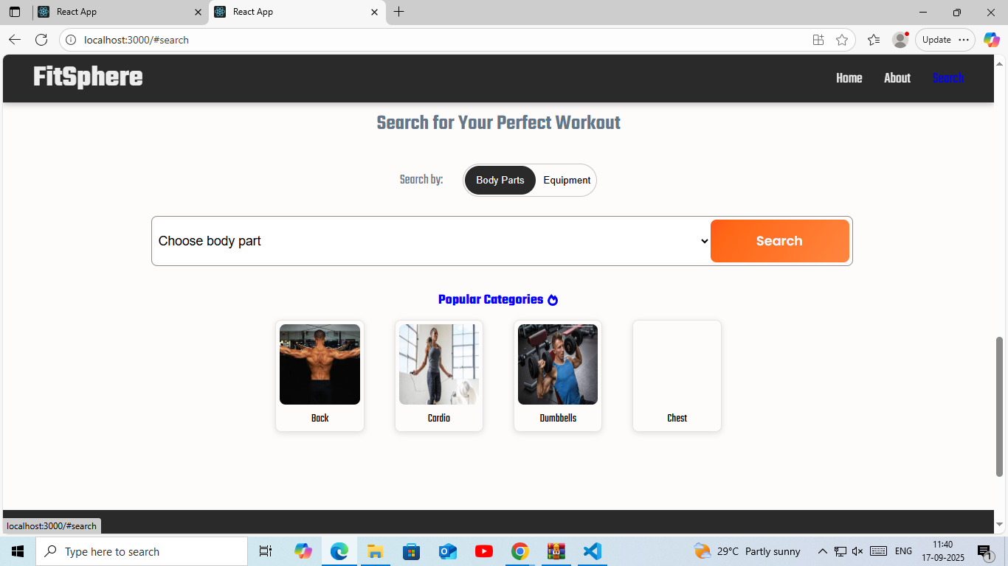

* 1. **STYLING**
* Tailwind CSS: For custom, flexible designs using a "utility-first" approach. Offers maximum control for a unique brand identity but has a steeper learning curve.
* Bootstrap: For quick, consistent builds using a comprehensive library of pre-built, mobile-first components and an easy-to-use grid system.
* Bulma: For lightweight and modular projects. It is based on Flexbox, uses no JavaScript, and is fully responsive by default.
* Specialty Libraries: To add flair to any project, libraries like Animate.css (for animations) and Balloon.css (for tooltips) can be used.

For aesthetic styling

* Color Palette: Use vibrant, high-energy colors like red or orange for a high-intensity feel. Use calming, natural tones like greens and blues for a wellness or yoga brand.
* Typography: Choose a bold, impactful sans-serif font for headlines and a clean, legible one for body text to ensure readability and convey strength.
* Visuals: Use high-quality, professional photography and videos of people working out. Include a diverse range of ages and body types. Use simple SVG icons for scalability.
* Layout and UX: Prioritize a responsive, mobile-first design with clear navigation, scannable sections, and touch-friendly elements. Use micro-animations to enhance user engagement.
  1. **TESTING**

Functional Testing: Verifies that all features work as expected. This includes testing user login, class booking, payment processing, search filters, and content management.

* Non-functional Testing: Evaluates the website's quality, such as its speed, security, and usability. Key tests include:
  + Performance Testing: Ensures the site handles traffic loads efficiently.
  + Compatibility Testing: Checks that the site works across different browsers and devices.
  + Security Testing: Protects user data and payments from vulnerabilities.

Usability Testing: Confirms the website is easy and intuitive to use.

* 1. 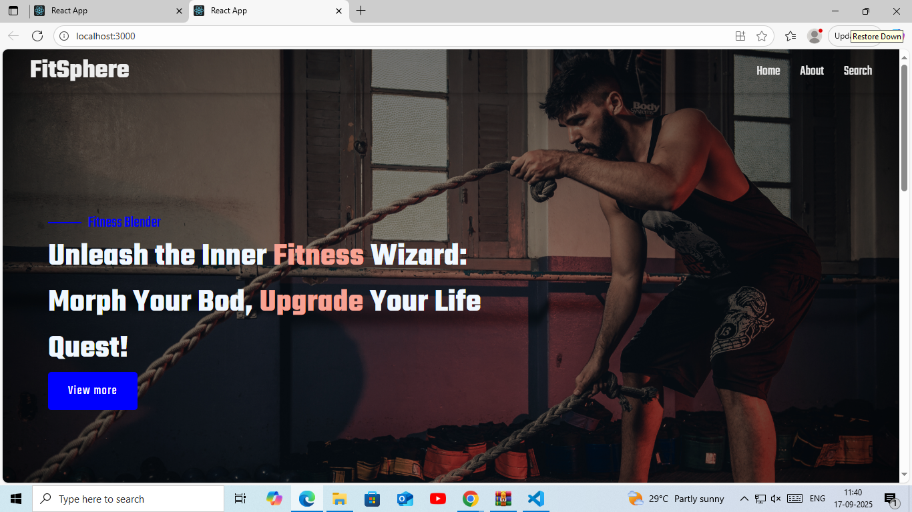**SCREENSHOTS**

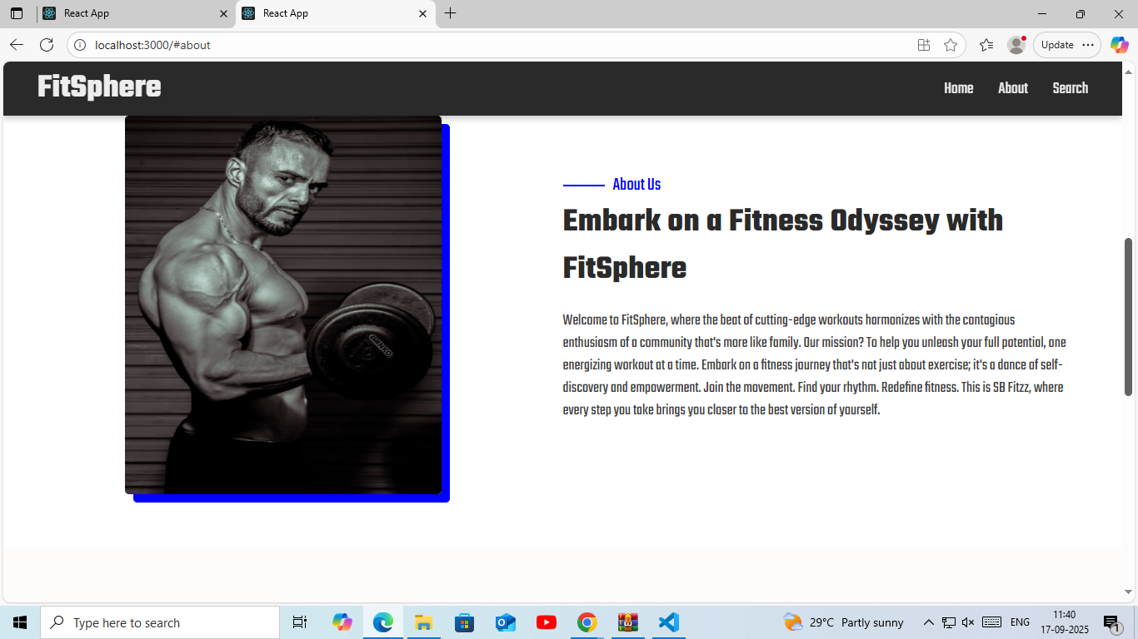

* 1. **KNOWN ISSUES**
* **Integrations with third-party devices:** Integrating the website with a wide range of wearable fitness trackers (like Fitbit and Apple Watch) and mobile apps is a significant challenge. Developers must constantly update integrations to remain compatible with evolving APIs and operating system updates.
* **Inaccurate activity tracking:** Different devices may report inconsistent data (e.g., step count or calories burned) due to sensor variations. Ensuring a high degree of accuracy and consistent tracking across all platforms is a persistent technical hurdle.
* **Performance and stability:** Features like video streaming for live or on-demand classes, real-time data syncs, and heavy AI-driven recommendations can cause slow loading times and glitches. This negatively impacts user experience and requires continuous optimization and testing.
* **Cross-platform performance:** Ensuring a responsive and seamless experience across various devices and screen sizes is essential. A single web platform must look and function correctly on desktops, tablets, and mobile phones, which can be challenging to maintain.
* **Offline support:** Supporting offline functionality for users who may be exercising in areas with poor internet connectivity is a difficult but often necessary feature for advanced fitness tracking.

User experience (UX) issues

* **Engagement and motivation:** It is difficult to keep users engaged and motivated for long-term use. Projects often struggle to find the right balance for gamification elements like badges and leaderboards, ensuring they are encouraging rather than overwhelming.
* **Overwhelming personalization:** While users want customized workout and diet plans, the process of providing enough data can feel complicated or intrusive. Designing an intuitive setup process that balances personalization with ease of use is a core issue.
* **Accessibility and inclusivity:** Many fitness websites primarily cater to a young, tech-savvy audience. It can be difficult to design for users of all fitness levels, ages, and abilities. For example, some platforms may neglect accessibility features for users with visual or hearing impairments.

**14. FUTURE ENHANCEMENT**

Embrace Virtual & Hybrid Fitness

* **High-Quality Live Streaming:**

Invest in robust, user-friendly platforms for live virtual classes and on-demand content to cater to the growing preference for at-home workouts.

* [**Virtual Reality (VR) & Augmented Reality (AR)**](https://www.google.com/search?sca_esv=2f32eac133bcd00b&cs=0&sxsrf=AE3TifMR8W5H3-NB9BTnuuPp9O-EpCqaZg%3A1758174000121&q=Virtual+Reality+%28VR%29+%26+Augmented+Reality+%28AR%29&sa=X&ved=2ahUKEwis9LLFzOGPAxV0ZWwGHdq9AXUQxccNegQIEhAB&mstk=AUtExfCGzoucjEwXaEGukrXcK2rP2rLR5GdDDu8S1c3UpzH3FhUztZ-FqUqbT36DjQ2aGHawnA-Ubb3S4O5fxXtbWVbNG-8mdXieKqZ5VY17EQ3fHadNWgnQvus2ApRWpB0JN345hse5AshnTEAlZ3DSsTgmgd4nqg7fLZbU5OLCnHBXVlcGKdMI3jpBCP4ZENMrHJlL4jE2RgkehGqwgDwWwi1gGQCR1MrAaXwj9Wt9dgJg8eAPMXbfHe_CEWntYsU51tLXam9x1U56OhYmryEJqjZu&csui=3)**:**

Integrate immersive VR/AR workouts that combine entertainment with exercise, making fitness more engaging and accessible.

Leverage Artificial Intelligence (AI)

* **Personalized Training:**

Utilize AI to create hyper-personalized workout plans and offer real-time adjustments based on performance, similar to having a virtual coach.

* [**AI-Powered Feedback**](https://www.google.com/search?sca_esv=2f32eac133bcd00b&cs=0&sxsrf=AE3TifMR8W5H3-NB9BTnuuPp9O-EpCqaZg%3A1758174000121&q=AI-Powered+Feedback&sa=X&ved=2ahUKEwis9LLFzOGPAxV0ZWwGHdq9AXUQxccNegQIIRAB&mstk=AUtExfCGzoucjEwXaEGukrXcK2rP2rLR5GdDDu8S1c3UpzH3FhUztZ-FqUqbT36DjQ2aGHawnA-Ubb3S4O5fxXtbWVbNG-8mdXieKqZ5VY17EQ3fHadNWgnQvus2ApRWpB0JN345hse5AshnTEAlZ3DSsTgmgd4nqg7fLZbU5OLCnHBXVlcGKdMI3jpBCP4ZENMrHJlL4jE2RgkehGqwgDwWwi1gGQCR1MrAaXwj9Wt9dgJg8eAPMXbfHe_CEWntYsU51tLXam9x1U56OhYmryEJqjZu&csui=3)**:**

Implement AI for body composition analysis and movement tracking to provide instant feedback and help users improve their form and prevent injuries.

* **Predictive Health:**

Integrate AI for emotional wellness tracking and predictive insights into potential health risks and injury prevention, offering more proactive wellness guidance.

Integrate Wearable Technology

* **Data-Driven Insights:**

Connect with advanced wearables to track heart rate, sleep, recovery, and other health metrics, using AI to offer actionable advice to users.

* **Holistic Health View:**

Use data from wearables to build a comprehensive view of user well-being, integrating physical activity with mental wellness tracking.

Enhance User Engagement & Personalization

* **Gamification:**

Incorporate game-like elements to make workouts more motivating and engaging, especially for users who are less active.

* **Mindfulness & Mental Health Features:**

Add tools for stress monitoring, guided meditations, and other calming sessions, recognizing the increasing importance of mental well-being.